Monday, February 27, 2006
NORMAN BULLETIN 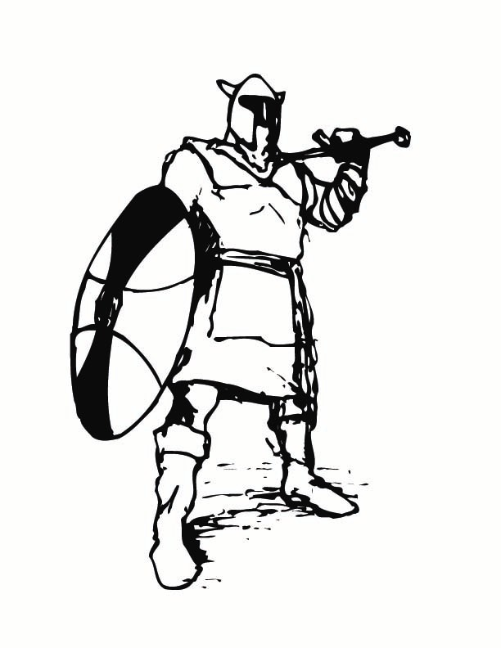
Published 3 times a week - Monday, Wednesday, Friday
“ How far that little candle throws his beams! So shines a good deed in a weary world”
~William Shakespeare

SCHEDULE FOR THE WEEK
Today Regular Schedule Staff Meeting 3:00 p.m. Room 300
Tuesday Regular Schedule
Wednesday Block Schedule
Thursday Block Schedule SEC Meeting 1:15 p.m. / BHEA Executive Board 3:45 p.m.
Friday Regular Schedule End of 5 week marking period

STAFF
THE LIBRARY’S MAGAZINE DISTRIBUTION of past issues has begun! Please return your request sheets, circling the titles you’d like. Forms are available at the sign-in bulletin board.

SENIORS
SENIORS – URGENT!! All CAL GRANT VERIFICATION FORMS are due to House A by Tuesday, Feb. 28th.
SMC Counselor will be on campus Tuesday, February 28, in the Career Center, room 292 @ 9:30 a.m.
SENIOR TEA MODEL & HOST APPLICATIONS will be available on Wednesday, March 1, in all Houses. Please be sure to pick up an application, fill in all needed information and return your application to House C by Wednesday March 15, 2006
SENIORS WHO HAVE BEEN OFFERED OR ACCEPTED TO NORTHERN ARIZONA UNIVERSITY are invited to attend a “Freshman Reception” on Sunday, March 5, at 2:00 p.m. at the Doubletree Hotel in Anaheim – 100 the City Drive, Orange 92868. Directions call (714) 634-4500 The event will be held a second day…Monday, March 6 at 7:00 p.m. at the Palm Garden Hotel, 495 N. Ventura Park Road, Thousand Oaks 91320 (805) 716-4200
SENIOR EDITION – If you would like to be in the 2006 Senior Edition of Highlights, please submit Senior Polls by March 3, 2006 and Senior Farewell’s and Baby Pictures by March 17, 2006, to room 253. Additional copies of the polls are also available in room 253.

SENIORS & JUNIORS
DO YOU HAVE A LEAST ONE ANCESTOR WHO EMIGRATED FROM ITALY? Are you interested in a Leadership/Government all-expenses paid Workshop to Washington D.C? Get more info at www.niaf.org/s21/2006

ALL STUDENTS
APPLICATIONS FOR HONORS/AP Studio Art are available in Room 262 from Mr. Federman, Interviews, applications, and portfolio submissions have begun; pick up the application Now and sign up for an interview date. The Board portfolio types are 2D Design, Drawing, and 3D Design. Don’t miss your opportunity… class space is limited!
AP EUROPEAN HISTORY, AP US HISTORY & AP GOVERNMENT/HONORS ECONOMICS applications will be available beginning Today from the Social Studies teachers. All completed applications must be turned in by Friday, March 10. Entrance tests for qualified applicants will be given on Wednesday, March 16, after school.
CONCERNED YOU OR A FRIEND MAY HAVE A DRUG OR ALCOHOL PROBLEM? Compulsive behavior? If so, please attend the Sober Lunch Meeting in room 521 Today. Everything said at the meeting is confidential. For more information, please see Dr. Wolfe in room 292.
NEED HELP IN A SUBJECT? Come to room 234 on Mondays and Tuesdays at lunch … Bring your lunch and get help!
HELP A CHILD IN AFRICA learn to read. Donate new and used books, encyclopedias, dictionaries, and magazines by Tuesday, February 28. Boxes will be placed in the library, all houses, and the attendance office. CHANGE THE WORLD…one book at a time!
HAVE YOU PRE-PAID FOR A 05-06 AGENDA? If so, please come to the student store at lunch and pick-up your copy prior to the Wednesday, March 1st deadline.
HAVE YOU BEEN FIGHTING WITH YOUR FRIENDS? Take a break from class and come to PEER MEDIATION. Blue sign up sheets are in the Main office.
NEED HELP WITH YOUR ENGLISH ASSIGNMENTS? Come to room 269 Wednesday morning from 8:00 – 9:30 for help.

SOCIETY OF WOMEN ENGINEERS is hosting a one day conference at Harvey Mudd College, Saturday, March 4, from 9:00 to 3:30 p.m. The conference offers young women aspiring to be scientists the opportunity to learn about careers in engineering, math, and science, AND offers interaction with professionals and other students. For more info, please email
Jamie at jshoffeitt@hmc.edu or call Gena at (909) 607-4275- check the bulletin board outside of House A
ATTENTION ARTISTS! Please submit your 8x11 black and white drawing for the cover of this year’s Voices Around the World Magazine by March 10. You can bring it to room 250 or to Mrs. Hinden’s mailbox in the main office.

CLUB MEETINGS/ACTIVITIES
ALL CLUB REPRESENTATIVES meet in room 504 Today regarding the “Diversity Fair”. You can make money and represent your club.
INSPIRATIONAL CLUB meeting Today regarding the group SAT. Everyone must come! Room 369 at lunch
CHRISTIAN CLUB meeting in room 404 Tuesday at lunch. Note date change. Come for a ton of Christian fun!
BSU mandatory meeting on Tuesday, Feb. 28, during lunch in room 703
BEST BUDDIES MANDATORY MEETING, Tuesday, February 28, at lunch in room 232. Important info regarding USC bash will be handed out.
THE ALI G CLUB will meet Tuesday in room 403 at lunch
DRAGON BALL Z CLUB will meet Tuesday in room 298. Come for a ton of Kamehameha Fun!
MORNING SERVICES will take place in room 234 on Wednesday at 8:30 a.m. sharp!! Please bring your kippa, suddur and tefflilin. Kosher breakfast will be served. Bring a friend.

ATHLETICS

LOST & FOUND
LOST - LeSport makeup bag with 3 zippers – makeup inside – Return to House B
LOST - Red USC hooded zipper jacket. Last seen in the Weight Room. If found, please return to the attendance office

